**3.** **Analysis**

Various analysis has been done throughout the process.

1. Comparison of download speeds in 4G between 2 operators i.eAirtel and Jio.

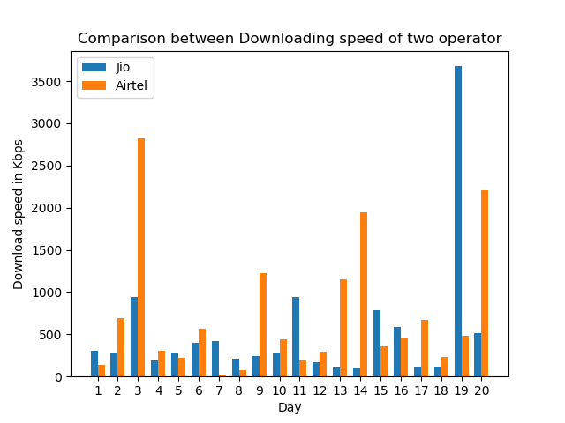

1. Comparison of upload speeds in 4G between 2 operators i.eAirtel and Jio.

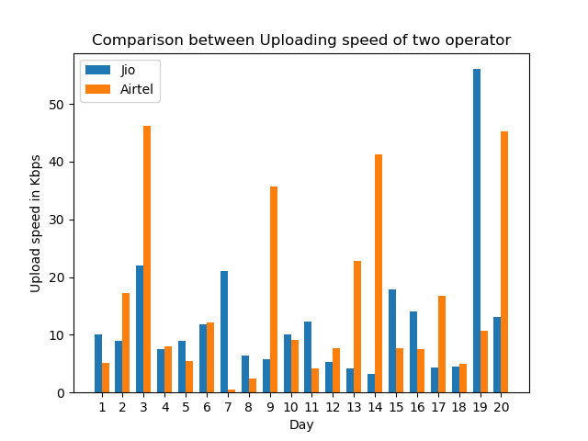

1. Comparison of Signal strengths in 2 platforms using different operators.

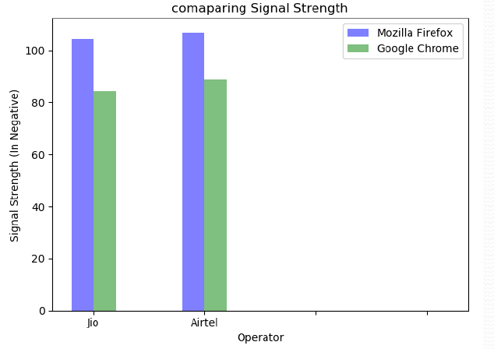

1. Comparison of download speeds in 3G and 4G using a single operator.

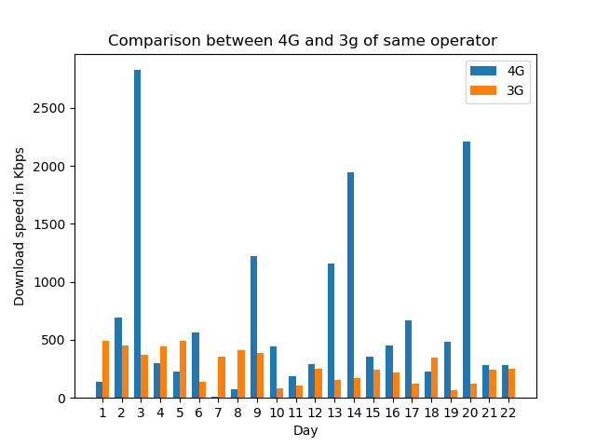

1. Comparison of upload speeds in 3G and 4G using a single operator.

